# Royal Comfort: Elevate Your Casual Look with Dike Fashions

Dike Fashions blends comfort with elegance, offering stylish casual wear for men, women, and kids at affordable prices. With premium fabrics and versatile designs, you can elevate everyday outfits into regal statements. Experience confidence and timeless fashion—make your casuals royal with Dike.

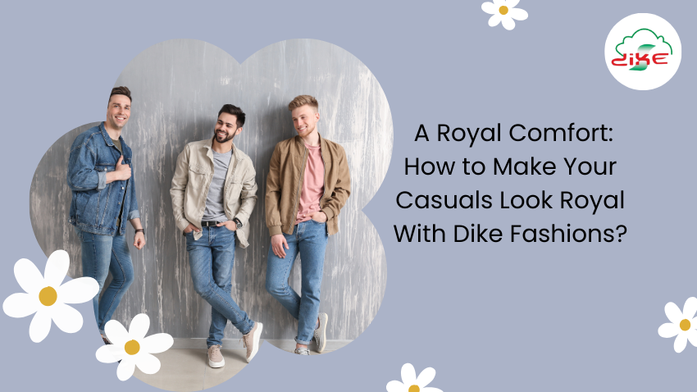

Click here : <https://dikefashions.com/2025/04/25/royal-comfort-elevate-your-casual-look-with-dike-fashions/>

#StyleWithComfort #CasualWear #RoyalComfort #EverydayElegance #WomenFashion

#DikeFashions #TrendyCasuals #ComfortAndStyle #Athleisure #LuxuryWear

#ModernCasuals #VersatileStyle #StyleWithComfort #TimelessFashion

#BestFashionBrand #BestAthleisureWear #BestAffordableFashion #BestComfortWearOnline

#BestOnlineFashionStore #OnlineFashionDeals #WomensBriefs #SoftLadiesBriefs

#FeelTheComfort